Resources
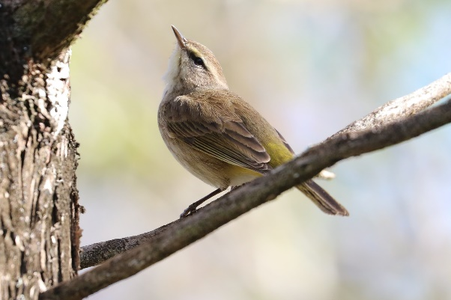
Palm Warbler
Articles
Keystone Plants https://www.pollinatorsnativeplants.com/softlandings.html
Soft Landings

Keystone Native Plants for Eastern Temperate Forests- Ecoregion 8
https://www.nwf.org/-/media/Documents/PDFs/Garden-for-Wildlife/Keystone-Plants/NWF-GFW-keystone-plant-list-ecoregion-8-eastern-temperate-forests.pdf?sc_lang=en&hash=C475FADDFCC2622C7539F25935F5DAA1

Light to Protect the Night https://darksky.org/app/legacy/2020/04/Light-to-Protect-the-Night-Five-Principles-for-Responsible-Outdoor-Lighting-IDAIES-01-e1587153343520-1.jpg

Plant Native Plants to Help Nature https://dnr.wisconsin.gov/topic/endangeredresources/nativeplants

Seven Simple Actions to Help the Birds https://www.birds.cornell.edu/home/seven-simple-actions-to-help-birds/

Ten Great Native Trees, Shrubs, and Plants for Birds https://p.widencdn.net/d0tla9/NH0533

Top Ten Native Shrubs for Wildlife https://www3.uwsp.edu/cnr-ap/UWEXLakes/Documents/resources/healthylakes/Top10forWildlife_LR_080111.pdf

Books
Birds of North America by Kenn Kaufman
Birds of Wisconsin by Stan Tekiela
Bird Trivia by Stan Tekiela
Bringing Nature Home by Douglas W. Tallamy
Landscaping with Native Plants of Wisconsin by Lynn M. Steiner
National Geographic Field Guide to the Birds of Eastern North America
Nature’s Best Hope by Douglas W.Tallamy
Plant a Pocket of Prairie by Phyllis Root (For children!)
Pollinators of Native Plants by Heather Holm
The Nature of Oaks by Douglas W. Tallamy
What It’s Like to be a Bird by David Allen Sibley
Wildflowers of Wisconsin and the Upper Midwest by Merrel R. Black and Emmet J. Judziewicz
Cedar Waxwing
Identifying Bird Calls
Birds of Wisconsin by Stan Tekiela
Merlin App for iPhone/Android
Who Cooks for Poor Sam Peabody? By John Feith (Bird Song Ear Training Guide)

Organizations
Central Wisconsin (local chapter) Wild Ones https://centralwisconsin.wildones.org/
Cornell Lab of Ornithology https://www.birds.cornell.edu/home/
National Wild Ones Website https://wildones.org/
Natural Resources Foundation of Wisconsin https://www.wisconservation.org/
North Central Conservancy Trust https://www.ncctwi.org/
NRF: The Bird Protection Fund https://www.wisconservation.org/grants/bird-protection-fund/
Project Feeder Watch https://feederwatch.org/
UWMadison Arboretum https://arboretum.wisc.edu/
Wisconsin Master Gardener https://mastergardener.extension.wisc.edu/
Wisconsin Master Naturalist https://wimasternaturalist.org/

Plant Identification
https://arboretum.wisc.edu/get-involved/friends/native-plant-sale/plant-info-sheets/
https://wisflora.herbarium.wisc.edu/index.php
https://www.inaturalist.org/

Where to Buy Native Plants: Sources
Agrecol Native Seed and Plant Nursery https://www.agrecol.com/
Generation Plant Nursery in Amherst, WI https://www.facebook.com/GenerationNativePlants
Local Farmshed sale in May https://www.stevenspointarea.com/listing/central-rivers-farmshed/983/
Prairie Moon Nursery https://www.prairiemoon.com/
Prairie Nursery https://www.prairienursery.com/
UW-Madison Arboretum sale in May https://foamadison.org/shop/
Wild Ones plant sale-(member discount) order in February https://centralwisconsin.wildones.org/

